Experiment: Time Scaling

A discrete time signal x(n) is shown in figure.

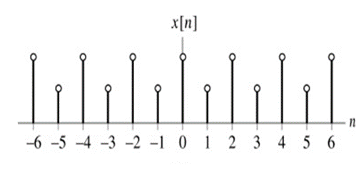

Sketch the signal x[n], the sketch y[n]=x[n/2].

Solution:-

close all;

clear all;

clc;

start_value = input('Enter the start value: ');%-6

end_value = input('Enter the end value: ');%6

n1 = start_value:end_value;

y=input("Enter the values of signal = "); %[1 0.5 1 0.5 1 0.5 1 0.5 1 0.5 1 0.5 1]

index=1;

n2=(2*start_value):(2*end_value);

for i=1:length(n2)

x1(i)=n2(i);

if(rem(n2(i),2)==0)

y1(i)=y(index);

index=index+1;

else

y1(i)=0;

end

end

subplot(2,1,1);

stem(n1,y,'r');

xlabel("Time");

ylabel("Amplitude");

grid on;

grid minor;

axis([(start_value-1) (end_value+1) -2 2]);

title("Original signal Y[n]=X[n]");

subplot(2,1,2);

stem(x1,y1,'b');

xlabel("Time");

ylabel("Amplitude");

grid on;

grid minor;

axis([(2*start_value-1) (2*end_value+1) -2 2]);

title("Compresion signal Y[n]=X[n/2]");

Original signal Y[n]=X[n]:-

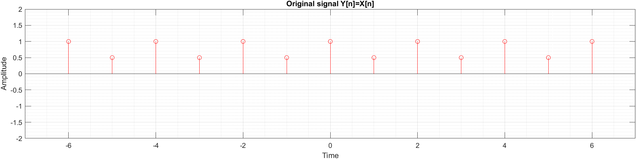

Compresion signal Y[n]=X[n/2]:-

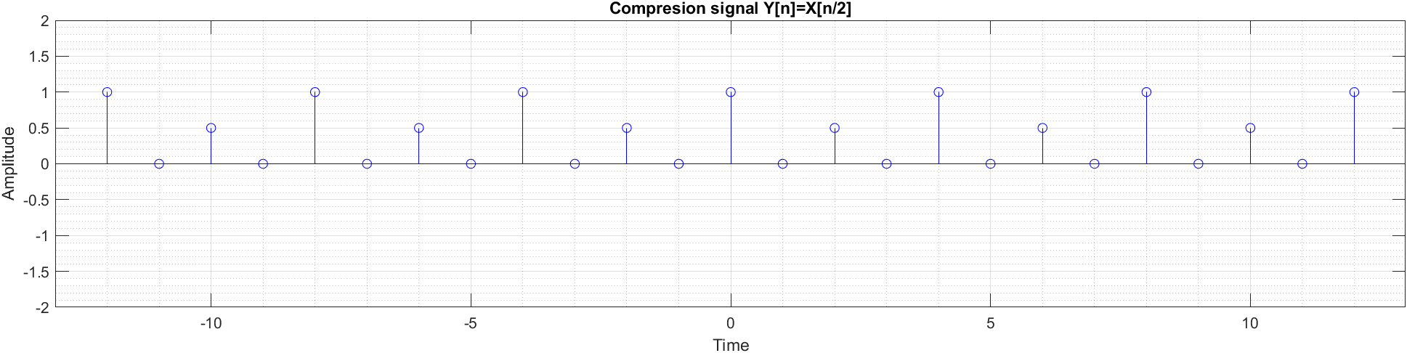

**Ankon Karmokar**